Come Run with us!
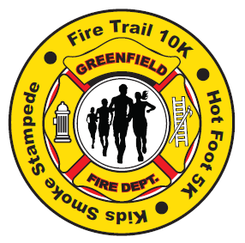
Help support the Greenfield Fire Department by joining us for our 2nd annual Hot Foot 5K+, Fire Trail 10K, or Kids ½ mile Smoke Stampede*! All proceeds go to the Greenfield Fire Department, a 501C3 non-profit organization.
Saturday April 29, 2017
Oak Park, 971 Forest Rd. Greenfield, NH
9:00 AM (Kids Smoke Stampede will begin at 8:30am)
T-shirts for first 50 runners/walkers registered before April 1, 2017 – T-shirts are for 5K+ and 10K participants only.
Part of a Fire Department? Register your team and compete with other area departments; first department to have 3 runners cross the finish line wins.
For more information or to register:
Visit www.active.com and search Greenfield, NH
Email gfdroadrace@aol.com to have information sheet, registration form and waiver form emailed to you.
Go to www.gfdroadrace.webs.com to view information and download forms

